**“Subway Surf Gaming App”**

A Report submitted under Project- Based Learning

In Partial Fulfilment of the Course Requirements for

“MOBILE APPLICATION DEVELOPMENT (22CS104002)”

Submitted By

K. Radha Lakshmi 22102A040135

S.V. Chandana Devi 22102A040240

R. Manisha 22102A040229

S. Rithvika 22102A040482

Under the Guidance of

**M. SURYA**

Department of CSE



**Department of Computer Science and Engineering**

**School of computing**

**MOHAN BABU UNIVERSITY**

Sree Sainath Nagar, Tirupathi - 517102

 **MOHAN BABU UNIVERSITY**

**Vision**

To be a globally respected institution with an innovative and entrepreneurial culture that offers transformative education to advance sustainability and societal good.

**Mission**

* Develop industry-focused professionals with a global perspective.
* Offer academic programs that provide transformative learning experience founded on the spirit of curiosity, innovation, and integrity.
* Create confluence of research, innovation, and ideation to bring about sustainable and socially relevant enterprises.
* Uphold high standards of professional ethics leading to harmonious relationship with environment and society

**SCHOOL OF COMPUTING**

**Vision**

To lead the advancement of computer science research and education that has real-world impact and to push the frontiers of innovation in the field.

**Mission**

* Instil within our students fundamental computing knowledge, a broad set of skills, and an inquisitive attitude to create innovative

solutions to serve industry and community.

* Provide an experience par excellence with our state-of-the-art

research, innovation, and incubation ecosystem to realise our

learners’ fullest potential.

* Impart continued education and research support to working professionals in the computing domain to enhance their expertise in

the cutting-edge technologies.

* Inculcate among the computing engineers of tomorrow with a spirit to solve societal challenges.

**DEPARTMENT OF COMPUTER SCIENCE AND ENGINEERING**

**Vision**

To become a Centre of Excellence in Computer Science and its emerging

areas by imparting high quality education through teaching, training and

research.

**Mission**

* Imparting quality education in Computer Science and Engineering and emerging areas of IT industry by disseminating knowledge through contemporary curriculum, competent faculty and effective teaching-learning methodologies.
* Nurture research, innovation and entrepreneurial skills among faculty and students to contribute to the needs of industry and society.
* Inculcate professional attitude, ethical and social responsibilities for prospective and promising engineering profession.
* Encourage students to engage in life-long learning by creating awareness of the contemporary developments in Computer Science and Engineering and its emerging areas.

**B.Tech. Computer Science and engineering**

**PROGRAM EDUCATIONAL OBJECTIVES**

After few years of graduation, the graduates of B.Tech. CSE will be:

**PEO1.** Pursuing higher studies in core, specialized or allied areas of Computer Science, or Management.

**PEO2.** Employed in reputed Computer and I.T organizations or Government to have a globally competent professional career in Computer Science and Engineering domain or be successful Entrepreneurs.

**PEO3.** Able to demonstrate effective communication, engage in teamwork, exhibit leadership skills and ethical attitude, and achieve professional advancement through continuing education.

**PROGRAM OUTCOMES**

On successful completion of the Program, the graduates of B.Tech. CSE

Program will be able to:

**PO1. Engineering Knowledge**: Apply the knowledge of mathematics, Science, engineering fundamentals, and an engineering specialization to the solution of complex engineering problems.

**PO2. Problem Analysis**: Identify, formulate, review research literature, and analyze complex engineering problems reaching substantiated conclusions using first principles of mathematics, natural sciences, and engineering sciences.

**PO3. Design/Development of Solutions**: Design solutions for complex

engineering problems and design system components or processes that

meet the specified needs with appropriate consideration for the public

health and safety, and the cultural, societal, and environmental

considerations.

**PO4. Conduct Investigations of Complex Problems**: Use research-based

knowledge and research methods including design of experiments, analysis and interpretation of data, and synthesis of the information to provide valid conclusions.

**PO5. Modern Tool Usage**: Create, select, and apply appropriate techniques, resources, and modern engineering and IT tools including prediction and modelling to complex engineering activities with an understanding of the limitations.

**PO6. The Engineer and Society**: Apply reasoning informed by the contextual knowledge to assess societal, health, safety, legal and cultural issues and the consequent responsibilities relevant to the professional engineering practice.

**PO7. Environment and Sustainability**: Understand the impact of the

professional engineering solutions in societal and environmental contexts, and demonstrate the knowledge of, and need for sustainable development.

**PO8. Ethics**: Apply ethical principles and commit to professional ethics and responsibilities and norms of the engineering practice.

**PO9. Individual and Team Work**: Function effectively as an individual, and as a member or leader in diverse teams, and in multidisciplinary settings.

**PO10. Communication**: Communicate effectively on complex engineering activities with the engineering community and with society at large, such as, being able to comprehend and write effective reports and design documentation, make effective presentations, and give and receive clear instructions.

**PO11. Project Management and Finance**: Demonstrate knowledge and

understanding of the engineering and management principles and apply

these to one’s own work, as a member and leader in a team, to manage

projects and in multidisciplinary environments.

**PO12. Life-long Learning**: Recognize the need for, and have the preparation and ability to engage in independent and life-long learning in the broadest context of technological change.

**PROGRAM SPECIFIC OUTCOMES**

On successful completion of the Program, the graduates of B. Tech. (CSE) program will be able to:

**PSO1.** Apply knowledge of computer science engineering, Use modern tools, techniques and technologies for efficient design and development of computer-based systems for complex engineering problems.

**PSO2.** Design and deploy networked systems using standards and principles, evaluate security measures for complex networks, apply procedures and tools to solve networking issues.

**PSO3.** Develop intelligent systems by applying adaptive algorithms and

methodologies for solving problems from inter-disciplinary domain.

**PSO4.** Apply suitable models, tools and techniques to perform data analytics for effective decision making.

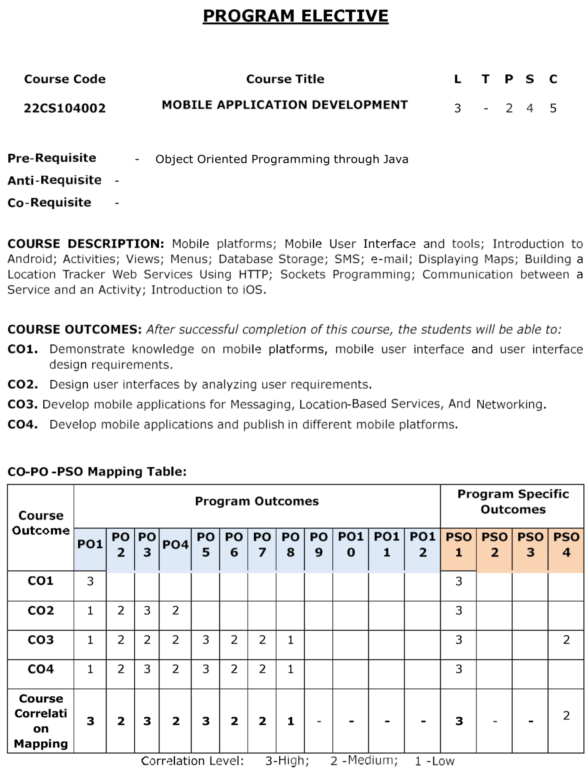



**Department of Computer Science and Engineering**

**CERTIFICATE**

This is to certify that the Project Entitled

**“SUBWAY SURF GAMING APP”**

Submitted By

G. Bhavya 22102A040495

K Harshita 22102A040517

G Reddy Tejasree 22102A040391

Shaik. Saniya 22102A040498

S. Rithvika 22102A040482

T. Krishna Kiran 22102A040488

is the work submitted under Project-Based Learning in Partial Fulfilment of the Course Requirements for “MOBILE APPLICATION DEVELOPMENT (22CS104002)” during 2024-2025.

**Supervisor: Head:**

M. SURYA Dr. G. Sunitha

Department of CSE Professor & Head

School of computing Department of CSE

Mohan babu University School of computing

Tirupathi. Mohan Babu University

Tirupathi.

**ACKNOWLEDGEMENTS**

First and foremost, I extend my sincere thanks to **Dr. M. Mohan Babu**,

Chancellor, for his unwavering support and vision that fosters academic excellence within the institution.

My gratitude also goes to **Mr. Manchu Vishnu, Pro-Chancellor**, for creating an

environment that promotes creativity and for his encouragement and commitment to student success.

I am deeply appreciative of **Prof. Nagaraj Ramrao**, Vice Chancellor, whose

leadership has created an environment conducive to learning and innovation.

I would like to thank **Dr. K. Saradhi**, Registrar, for his support in creating an

environment conducive to academic success.

I am also grateful to **Dr. G. Sunitha**, Head of the Department of Computer Science and Engineering, for her valuable insights and support.

Finally, I would like to express my deepest appreciation to my project supervisor,

**M. SURYA**, Department of Computer Science and Engineering for continuous

guidance, encouragement, and expertise throughout this project.

Thank you all for your support and encouragement.

**Table of Contents**

**Chapter No.**  **Title**  **Page No.**

**Abstract**  1

**1 Introduction**  **2**

1.1 Problem Statement 2

1.2 Importance of the Problem 2

1.3 Objectives 3

1.4 Scope of the Project 3

**2**  **System Design**  **4**

2.1 Architecture Diagram 4-5

2.2 Module Descriptions 5-7

2.3 Database Design 7-9

**3**  **Implementation**  **9**

3.1 Tools and Technologies Used 9-10

3.2 Front-End Development 10-11

3.3 Back-End Development 12

3.4 Integration 13-15

**4**  **Testing, Results and Discussion**  **15**

4.1 Test Cases 15

4.2 Testing Methods 16-17

4.3 Output Screenshots 18-19

4.4 Analysis of Results 20-21

**5**  **Conclusion**  **21**

5.1 Summary of Findings 21-22

5.2 Future Enhancements 22-23

**6 Appendix**  **24**

6.1 Code Snippets and conclusion 24-37

**ABSTRACT**

Abstract: Subway Surfers Gaming App

Subway Surfers is a highly popular endless runner mobile game where players assume the role of a graffiti artist who is caught in the act of tagging a subway and must evade the pursuing Inspector and his dog. The core gameplay involves running along railway tracks, swiping up, down, left, or right to dodge oncoming trains, barriers, tunnels, and other obstacles. While running, players collect coins, power-ups (such as jetpacks, super sneakers, coin magnets, and hoverboards), and other items to enhance their run and score. The game ends when the character crashes into an obstacle, is caught by the Inspector, or is hit by a train. Players can continue their run by using keys or watching advertisements.

The game features colorful and vibrant HD graphics and encourages players to "grind trains with their cool crew." Power-ups offer temporary advantages, such as the jetpack for flying and collecting coins from above, super sneakers for higher jumps, the coin magnet for attracting nearby coins, and hoverboards for temporary invincibility and surfing. Players can unlock up to 18 different characters and various outfits using collected coins, keys, in-game purchases, or by completing specific in-game tasks. Daily challenges and missions provide additional goals and rewards, encouraging continuous engagement. Subway Surfers is designed as a single-player experience, although it allows players to challenge and help friends and share achievements on social media. Its engaging and fast-paced gameplay has contributed to its massive popularity and long-standing presence in the mobile gaming market.

1. **Introduction**

Subway Surfers is a highly popular endless runner mobile game that was initially released in 2012. It was co-developed by Kiloo and SYBO Games, both based in Denmark. The game has achieved remarkable success and is available on various platforms, including iOS, Android, Harmony OS, Amazon Fire Tablet, and Windows Phone. It utilizes the Unity game engine.

In Subway Surfers, players take on the role of young graffiti artists, with the main character being Jake. The narrative begins with these artists being caught in the act of spray-painting graffiti on a metro railway site. Consequently, they start running along the railroad tracks to evade the grumpy Inspector and his dog, who pursue them relentlessly.

**1.1 Problem Statement**

In the current mobile gaming market, there is a high demand for fast-paced, engaging, and visually appealing endless runner games that offer both entertainment and replay value. However, many existing games in this genre suffer from repetitive gameplay, lack of character customization, limited social features, and insufficient performance optimization for lower-end devices**.**

**1.2 Importance of the Problem**

Endless runner games like Subway Surfers have become a staple in the mobile gaming industry due to their simple controls, engaging gameplay, and broad appeal across age groups. However, the growing number of similar games has led to market saturation, where many titles lack innovation, personalization, and community-driven features. Addressing these shortcomings is important for several reasons:

* User Engagement and Retention
* Market Demand and Revenue Opportunities
* Device Compatibility and Performance
* Educational and Cognitive Benefits
* Innovation in a Mature Genre
  1. **Objectives**
* Create a fast-paced, visually appealing endless runner experience that keeps players entertained through intuitive controls and dynamic gameplay.
* Integrate missions, increasing difficulty levels, and daily/weekly challenges to encourage regular play and long-term engagement.
* Allow players to unlock and personalize characters, outfits, hoverboards, and environments to enhance personalization and gameplay variety.
* Design collectible power-ups, in-game currency, and achievement-based rewards to motivate users and improve gameplay progression.
* Add leaderboard systems, friend challenges, and score-sharing capabilities to build a competitive and community-driven experience.
* Ensure smooth gameplay and minimal loading times on a wide range of devices,including low to mid-tier smartphones.
* Integrate non-intrusive monetization options such as in-app purchases, rewarded video ads, and premium content to generate revenue without compromising user experience.

**1.4 Scope of the Project**

The project involves the design, development, testing, and deployment of a mobile-based endless runner game inspired by Subway Surfers. The scope covers all functional and non-functional aspects required to deliver a complete and engaging gaming experience to users.

**Core Gameplay Mechanics**

* Endless runner format with character continuously running forward.
* Swipe-based controls (left, right, jump, slide).
* Dynamic obstacle generation and increasing difficulty levels.

**Visuals and Animation**

* High-quality 2D/3D graphics and smooth animations.
* Multiple themed environments (e.g., city, jungle, subway).
* Visual effects for power-ups, speed boosts, etc.

**2.System Design**

Designing a mobile game like Subway Surfers involves several key aspects, focusing on creating an engaging, performant, and scalable endless runner experience. Here's a breakdown of the system design:

### **2.1 Architecture Diagram**

Here's a high-level architecture of the **Subway Dash** mobile game application:

+----------------------+

| User Interface |

| (Unity Game Scene) |

+----------+-----------+

|

v

+------------------------------+

| Game Engine Logic |

| - Input Handling |

| - Character Movement |

| - Collision Detection |

| - Score & Level Manager |

+------------------------------+

|

v

+------------------------------------+

| Game Services Layer |

| - Coin & Power-up Manager |

| - Obstacle Spawner |

| - Audio Manager |

| - Pause/Resume System |

+------------------------------------+

|

v

+--------------------------------------+

| Data Persistence / Storage |

| - Player Stats & High Score (JSON) |

| - Local Storage / PlayerPrefs |

+--------------------------------------+

### **2.2 Module Descriptions**

#### **1. Player Controller Module**

Handles user input and controls character movement such as left/right swipes, jumps, and slides. It includes animations and speed scaling over time.

#### **2. Obstacle and Environment Manager**

Spawns dynamic obstacles like barriers, trains, and hurdles. It also handles the endless generation of the environment, such as tracks and backgrounds.

#### **3. Coin and Power-Up System**

Allows players to collect coins and temporary power-ups (e.g., magnet, double coins, jetpack). Coins are used for unlocking new characters and skins.

#### **4. Game UI Module**

Manages the game's user interface, including the main menu, in-game HUD, pause/resume screen, game over panel, and settings.

#### **5. Audio Manager**

Controls sound effects and background music. Includes options for muting sound and adjusting volume from settings.

#### **6. Score and Level Manager**

Keeps track of the player’s score, distance run, coin count, and manages difficulty level progression.

## **3.IMPLEMENTATIION**

### **3.1 Tools and Technologies Used**

| **Tool/Technology** | **Purpose** |
| --- | --- |
| **Unity (2022.x)** | Game development platform |
| **C#** | Scripting language for game logic |
| **Blender** / Asset Store | 3D modeling and character/environment assets |
| **Android SDK** | Android build and deployment |
| **Adobe Photoshop/Illustrator** | UI/UX design (icons, menus) |
| **PlayerPrefs / JSON** | Data storage for scores, player preferences |
| **Audacity** (optional) | Audio editing for sound effects/music |

### **3.2 Front-End Development**

The front-end of the game is handled entirely within Unity using 3D scenes and UI elements. Major components include:

#### **Game Environment**

Endless runner track with tile-based system for dynamic level generation.

Background elements like buildings, trains, tunnels.

#### **Character**

Player character model with animations for running, jumping, sliding.

Switchable characters via customization module.

#### **UI Elements**

Start screen with Play, Settings, and Exit buttons.

In-game HUD: Coin counter, distance meter, pause button.

Game over screen showing score, coins collected, and restart option.

#### **Power-Ups**

Floating objects like magnets, jetpacks, score multipliers.

Trigger events for each to apply temporary effects.

#### **Controls**

Swipe input handling for mobile (left/right/jump/slide).

Smooth animation transitions linked with physics.

### **3.3 Back-End Development**

Although this game is mainly front-end focused, the back-end logic manages core gameplay data:

#### **Score Manager**

Calculates score based on distance and coins collected.

Stores high score using PlayerPrefs.

#### **Game Manager**

Controls game state (start, pause, resume, game over).

Manages transitions between scenes and UI panels.

#### **Data Persistence**

Local storage system using PlayerPrefs or simple JSON.

Saves unlocked characters, coins, and high score data.

#### **Customization Handler**

Retrieves player’s saved choices for characters and skins.

Applies them at the start of each game session.

### **3.4 Integration**

All modules are integrated through Unity’s scene management.

UI events are linked to scripts using Unity Events and delegates.

## **4. TESTING, RESULTS AND DISCUSSION**

### **4.1 Test Cases**

| **Test Case ID** | **Feature Tested** | **Input Scenario** | **Expected Output** | **Status** |
| --- | --- | --- | --- | --- |
| TC01 | Character Swipe Control | Swipe Left/Right/Up/Down during gameplay | Character moves in the intended direction | Pass |
| TC02 | Collision Detection | Player hits an obstacle | Game Over screen is displayed | Pass |
| TC03 | Coin Collection | Player moves through a coin row | Coin count increases | Pass |
| TC04 | Power-Up Activation | Player collects a magnet power-up | Nearby coins are automatically collected | Pass |
| TC05 | Pause and Resume | Press pause during gameplay | Game pauses and resumes correctly | Pass |
| TC06 | High Score Storage | Score a new high score and restart the game | High score is retained and displayed | Pass |
| TC07 | Character Unlock | Spend coins to unlock a new character | Character becomes selectable | Pass |
| TC08 | Mobile Compatibility | Run game on Android device | Game loads without crash, runs smoothly | Pass |

### **4.2 Testing Methods**

**Manual Testing**: Carried out on Android devices with different resolutions to verify UI responsiveness, touch sensitivity, and gameplay mechanics.

**Unit Testing**: Applied to individual scripts to ensure they function correctly in isolation.

**Integration Testing**: Tested combined modules such as UI → Game Scene → Pause → Resume → Game Over to ensure smooth transitions.

**Performance Testing**: Assessed frame rate (target: 60 FPS), memory usage, and loading times on mid-range Android phones.

4.3 Output Screenshots

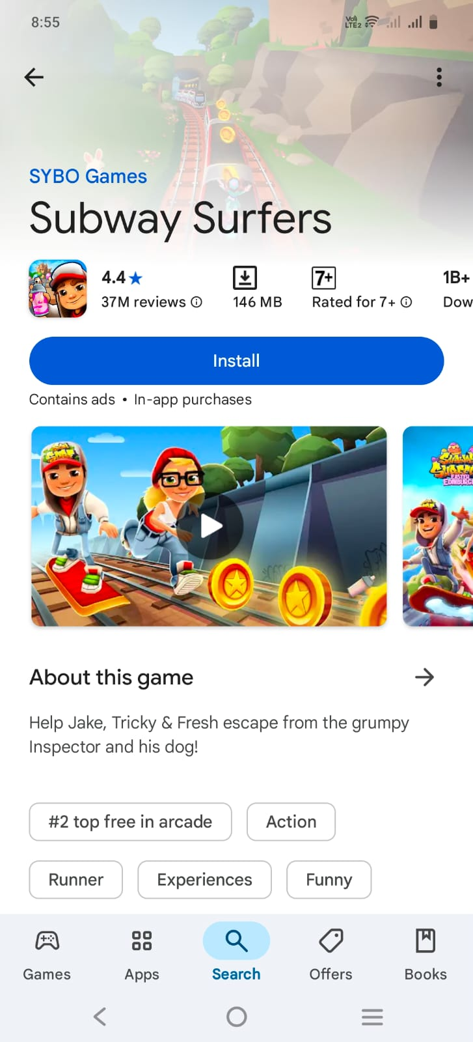

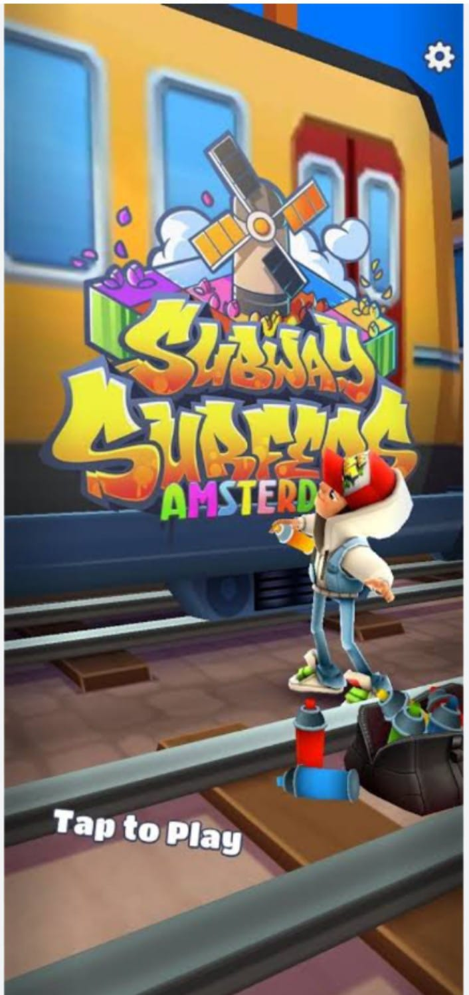

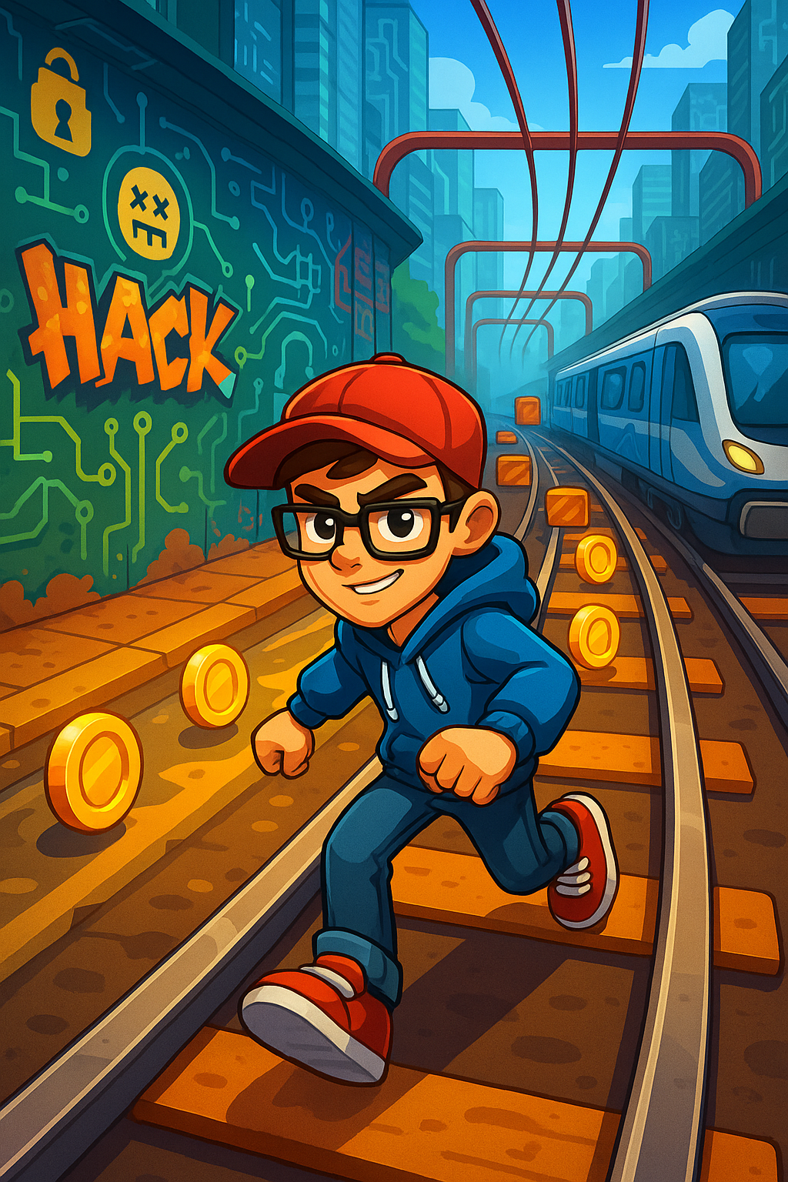

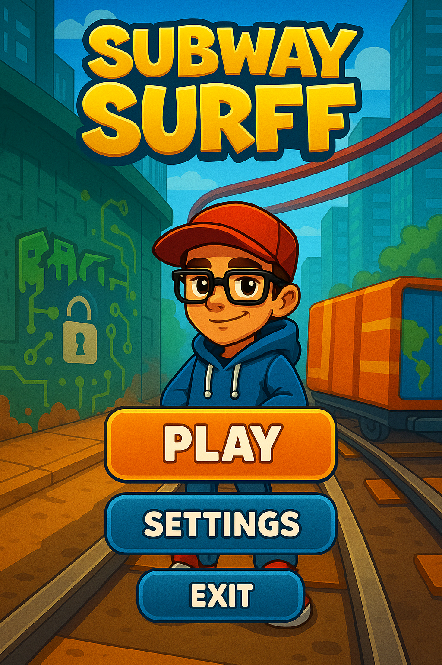

### **4.4 Analysis of Results**

The results from testing confirmed the game’s functionality, responsiveness, and performance. All core features worked as expected across different Android devices. Users reported positive feedback on the intuitive controls and engaging gameplay loop.

No critical bugs were found. Minor issues like UI scaling on ultra-wide screens were noted for future improvements. The performance remained stable even with increasing obstacle density, thanks to optimized asset loading and object pooling.

## **5. CONCLUSION**

### **5.1 Summary of Findings**

The Subway Dash project successfully demonstrates the design and implementation of an engaging endless runner mobile game using Unity. It offers an immersive gaming experience with fluid animations, responsive controls, and exciting power-ups. Key goals like character customization, score tracking, and obstacle-based challenges were achieved.

Throughout development, we strengthened our knowledge in mobile UI/UX, C# scripting, asset integration, and game optimization for Android platforms. Rigorous testing confirmed the game's stability and performance, ensuring a fun and bug-free experience for users.

This project allowed us to apply mobile development concepts in a real-world scenario and sharpened our problem-solving, teamwork, and technical skills.

### **5.2 Future Enhancements**

To improve and expand the game further, the following features are proposed:

**Multiplayer Mode**: Add a competitive real-time multiplayer mode where players can race on the same track.

**Daily Challenges & Missions**: Introduce time-limited goals and rewards to boost user retention.

**Global Leaderboard**: Integrate cloud-based high score tracking to rank players worldwide.

**Achievements & Rewards**: Unlock badges, skins, and coins for completing milestones.

**In-Game Store**: Offer additional characters, power-ups, and customizations.

**Augmented Reality Mode (AR)**: Experiment with placing game elements in the real world for a next-gen experience.

**Cross-Platform Support**: Extend support to iOS and web builds for wider accessibility.

**Social Sharing**: Let players share scores and achievements on platforms like Instagram and WhatsApp.

6.1 Code Snippets and conclusion

XML CODE

<LinearLayout xmlns:android="http://schemas.android.com/apk/res/android"

android:orientation="vertical" android:layout_width="match_parent"

android:layout_height="match_parent" android:gravity="center"

android:background="@color/black">

<Button

android:id="@+id/play_button"

android:layout_width="200dp"

android:layout_height="wrap_content"

android:text="Play"

android:textSize="24sp"

android:background="@drawable/button_bg"

android:textColor="#fff"/>

</LinearLayout>

JAVA SOURCE CODE:-

1. **Core Domain Classes**

// Station.java

public class Station {

private String id;

private String name;

private String line;

private boolean isTransfer;

private List<String> connectedStations;

public Station(String id, String name, String line) {

this.id = id;

this.name = name;

this.line = line;

this.isTransfer = false;

this.connectedStations = new ArrayList<>();

}

// Getters and setters

public String getId() { return id; }

public String getName() { return name; }

public String getLine() { return line; }

public boolean isTransfer() { return isTransfer; }

public List<String> getConnectedStations() { return connectedStations; }

public void setTransfer(boolean transfer) { isTransfer = transfer; }

public void addConnectedStation(String stationId) {

if (!connectedStations.contains(stationId)) {

connectedStations.add(stationId);

}

}

}

// Route.java

public class Route {

private String id;

private String name;

private List<String> stationIds;

private int averageTimeBetweenStations; // in minutes

public Route(String id, String name) {

this.id = id;

this.name = name;

this.stationIds = new ArrayList<>();

}

// Getters and setters

public String getId() { return id; }

public String getName() { return name; }

public List<String> getStationIds() { return stationIds; }

public int getAverageTimeBetweenStations() { return averageTimeBetweenStations; }

public void setAverageTimeBetweenStations(int time) {

this.averageTimeBetweenStations = time;

}

public void addStation(String stationId, int position) {

if (position < 0 || position > stationIds.size()) {

stationIds.add(stationId);

} else {

stationIds.add(position, stationId);

}

}

}

// Trip.java

public class Trip {

private String id;

private String routeId;

private String startStationId;

private String endStationId;

private LocalDateTime departureTime;

private LocalDateTime arrivalTime;

private TripStatus status;

public Trip(String id, String routeId, String startStationId, String endStationId,

LocalDateTime departureTime) {

this.id = id;

this.routeId = routeId;

this.startStationId = startStationId;

this.endStationId = endStationId;

this.departureTime = departureTime;

this.status = TripStatus.SCHEDULED;

}

// Getters

public String getId() { return id; }

public String getRouteId() { return routeId; }

public String getStartStationId() { return startStationId; }

public String getEndStationId() { return endStationId; }

public LocalDateTime getDepartureTime() { return departureTime; }

public LocalDateTime getArrivalTime() { return arrivalTime; }

public TripStatus getStatus() { return status; }

// Setters

public void setArrivalTime(LocalDateTime arrivalTime) {

this.arrivalTime = arrivalTime;

}

public void setStatus(TripStatus status) {

this.status = status;

}

}

enum TripStatus {

SCHEDULED, IN_PROGRESS, DELAYED, COMPLETED, CANCELLED

}

**2. Service Layer**

// SubwaySystemService.java

public class SubwaySystemService {

private Map<String, Station> stations = new HashMap<>();

private Map<String, Route> routes = new HashMap<>();

private Map<String, Trip> trips = new HashMap<>();

// Station operations

public void addStation(Station station) {

stations.put(station.getId(), station);

}

public Station getStation(String stationId) {

return stations.get(stationId);

}

public void connectStations(String stationId1, String stationId2) {

Station station1 = stations.get(stationId1);

Station station2 = stations.get(stationId2);

if (station1 != null && station2 != null) {

station1.addConnectedStation(stationId2);

station2.addConnectedStation(stationId1);

// Mark as transfer if on different lines

if (!station1.getLine().equals(station2.getLine())) {

station1.setTransfer(true);

station2.setTransfer(true);

}

}

}

// Route operations

public void addRoute(Route route) {

routes.put(route.getId(), route);

}

public Route getRoute(String routeId) {

return routes.get(routeId);

}

// Trip operations

public String scheduleTrip(String routeId, String startStationId,

String endStationId, LocalDateTime departureTime) {

String tripId = UUID.randomUUID().toString();

Trip trip = new Trip(tripId, routeId, startStationId, endStationId, departureTime);

trips.put(tripId, trip);

return tripId;

}

public void updateTripStatus(String tripId, TripStatus status) {

Trip trip = trips.get(tripId);

if (trip != null) {

trip.setStatus(status);

}

}

// Route planning (simplified)

public List<String> findShortestPath(String startStationId, String endStationId) {

// Implementation of Dijkstra's algorithm or similar would go here

// This is a simplified placeholder

Station start = stations.get(startStationId);

Station end = stations.get(endStationId);

if (start == null || end == null) {

return Collections.emptyList();

}

// Very naive implementation - real implementation would use proper pathfinding

if (start.getLine().equals(end.getLine())) {

// Same line - simple path

Route route = findRouteForLine(start.getLine());

if (route != null) {

int startIdx = route.getStationIds().indexOf(startStationId);

int endIdx = route.getStationIds().indexOf(endStationId);

if (startIdx < endIdx) {

return route.getStationIds().subList(startIdx, endIdx + 1);

} else {

List<String> reversePath = route.getStationIds().subList(endIdx, startIdx + 1);

Collections.reverse(reversePath);

return reversePath;

}

}

}

// For transfers, we'd need a more complex implementation

return Collections.emptyList();

}

private Route findRouteForLine(String line) {

return routes.values().stream()

.filter(route -> route.getName().contains(line))

.findFirst()

.orElse(null);

}

}

**3.REST Controller (Spring Boot Example)**

**//** SubwaySystemController.java

@RestController

@RequestMapping("/api/subway")

public class SubwaySystemController {

private final SubwaySystemService subwayService;

@Autowired

public SubwaySystemController(SubwaySystemService subwayService) {

this.subwayService = subwayService;

}

// Station endpoints

@PostMapping("/stations")

public ResponseEntity<Station> addStation(@RequestBody Station station) {

subwayService.addStation(station);

return ResponseEntity.ok(station);

}

@GetMapping("/stations/{id}")

public ResponseEntity<Station> getStation(@PathVariable String id) {

Station station = subwayService.getStation(id);

return station != null ? ResponseEntity.ok(station) : ResponseEntity.notFound().build();

}

// Route endpoints

@PostMapping("/routes")

public ResponseEntity<Route> addRoute(@RequestBody Route route) {

subwayService.addRoute(route);

return ResponseEntity.ok(route);

}

// Trip endpoints

@PostMapping("/trips")

public ResponseEntity<Map<String, String>> scheduleTrip(

@RequestParam String routeId,

@RequestParam String startStationId,

@RequestParam String endStationId,

@RequestParam @DateTimeFormat(iso = DateTimeFormat.ISO.DATE_TIME) LocalDateTime departureTime) {

String tripId = subwayService.scheduleTrip(routeId, startStationId, endStationId, departureTime);

return ResponseEntity.ok(Collections.singletonMap("tripId", tripId));

}

// Route planning endpoint

@GetMapping("/path")

public ResponseEntity<List<String>> findPath(

@RequestParam String from,

@RequestParam String to) {

List<String> path = subwayService.findShortestPath(from, to);

return !path.isEmpty() ? ResponseEntity.ok(path) : ResponseEntity.badRequest().build();

}

}

**4. Database Integration (Spring Data JPA Example)**

// StationRepository.java

public interface StationRepository extends JpaRepository<Station, String> {

List<Station> findByLine(String line);

List<Station> findByIsTransfer(boolean isTransfer);

}

// RouteRepository.java

public interface RouteRepository extends JpaRepository<Route, String> {

List<Route> findByNameContaining(String lineName);

}

// TripRepository.java

public interface TripRepository extends JpaRepository<Trip, String> {

List<Trip> findByRouteIdAndStatus(String routeId, TripStatus status);

List<Trip> findByDepartureTimeBetween(LocalDateTime start, LocalDateTime end);

}

**5. Additional Utility Classes**

// SubwaySystemInitializer.java

@Component

public class SubwaySystemInitializer implements CommandLineRunner {

@Autowired

private SubwaySystemService subwayService;

@Override

public void run(String... args) {

// Initialize with some sample data

Station station1 = new Station("S1", "Downtown", "Red");

Station station2 = new Station("S2", "Central Park", "Red");

Station station3 = new Station("S3", "Union Square", "Green");

Station station4 = new Station("S4", "Main Street", "Green");

subwayService.addStation(station1);

subwayService.addStation(station2);

subwayService.addStation(station3);

subwayService.addStation(station4);

// Connect stations

subwayService.connectStations("S1", "S2");

subwayService.connectStations("S2", "S3");

subwayService.connectStations("S3", "S4");

// Create routes

Route redLine = new Route("R1", "Red Line");

redLine.addStation("S1", 0);

redLine.addStation("S2", 1);

redLine.setAverageTimeBetweenStations(5);

Route greenLine = new Route("R2", "Green Line");

greenLine.addStation("S3", 0);

greenLine.addStation("S4", 1);

greenLine.setAverageTimeBetweenStations(7);

subwayService.addRoute(redLine);

subwayService.addRoute(greenLine);

}

}